**FSK DEMODULATION**

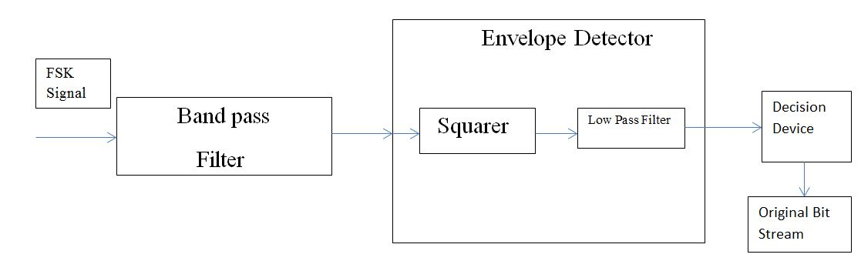

The above block diagram shows the complete process of demodulation of an FSK signal.

The FSK signal is composed of two sinusoidal waves of frequencies

1. 1MHz for bit ‘0’
2. 1.15MHz for bit ‘1’

The demodulation process is

1. Band pass Filter: The band pass filter is centered about 1MHz. That is, the sine wave representing 0 was passed while the sine wave representing 1(1.15MHz) was attenuated. An impulse response of unit value was used to model the band pass filter.

The impulse response is of order 10.

The band pass filter was implemented by convolving the FSK signal with impulse response.

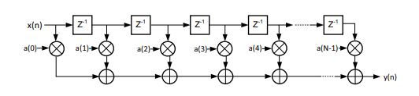

The above structure was followed for the convolution

The output of the band pass filter can be written as follows

Σk=0n(h(k)*x(n-k))=h(0)*x(n)+h(1)*x(n-1)+h(2)*x(n-2)+h(3)*x(n-3)…

NOTE: Whenever we use a uniform value of impulse response for a filter i.e., equal for all sampling times, there is an observable difference between the amplitude of the waveform resulting from that filter. So in reality both the waves increase in magnitude after passing through the filter but the increase in the higher frequency is lower than that of the lower frequency.

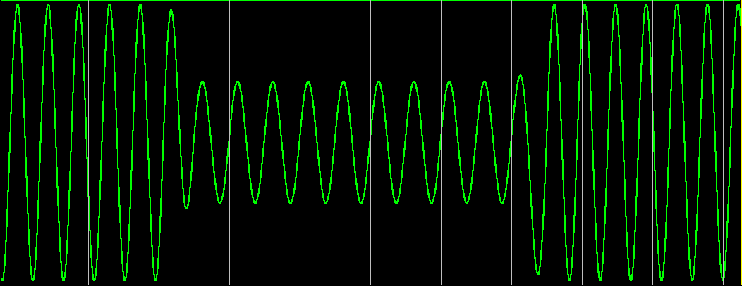

1. Envelope Detector
2. Squarer: The output of the band pass filter is squared to enable proper envelope detection. Because of squaring, the frequency of both 1MHz and 1.15MHz signals are doubled.

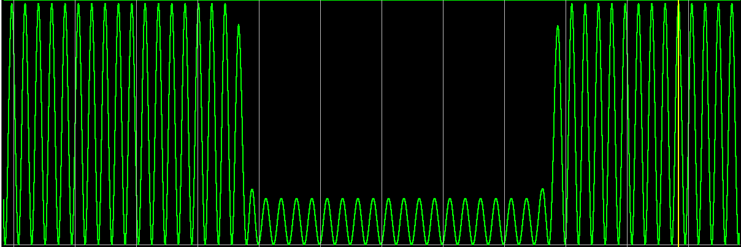

1. Low Pass Filter: A unit impulse response filter of order 5 was designed. This attenuated the both the frequencies further and detected a noisy envelope as shown.

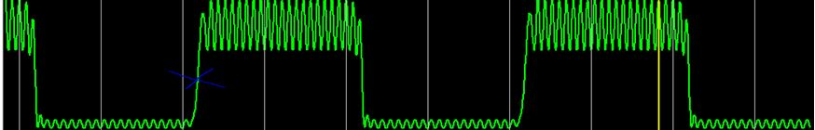

Theory:

Consider a sinusoidal wave Acos(θ).

After squaring it, we get A2cos2(θ)

This can be written as A2(1+cos(2θ))/2 = (A2+A2cos(2θ))/2.

Now when this is passed to the low pass filter, the higher frequency component A2cos(2θ) is filtered out. This leaves us with A2 which is by definition, the envelope of the squared waveform.

1. Decision Maker: The noisy envelope output from the low pass filter is passed to a decision device. A threshold value is set(as shown by the blue cross in the above figure) and any value above it is taken to be 0 and any value below it is taken to be 1.

After this, we take the complement of the resulting bit stream to get the original input bit stream because we had designed band pass filter for 1MHz which corresponds to bit ‘0’.

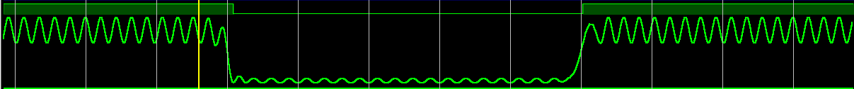

The waveform above has the envelope below and the bit stream above it.

The bit stream was verified to be having a bit rate of 100kbps which is as required.